Case Based Reasoning

CBR foundations
Minsky, Schank, Abelson and even Winston or others gave general directions for reusing past schemes for applying them to new situations in order to solve new problems.
We focus on Minsky and Schank pioneers works and interested reader could find biographical information about them in [Crevier 93] for example.

Marvin MINSKY draws main lines of what we could call “Stereotypes Based Reasoning”
See [Minsky 75] [http://web.media.mit.edu/~minsky/papers/Frames/frames.html]

Marvin Minsky argues that usual theoretical approaches in AI try to be too “precise”, local and not really structured to face “real world” problems. He considers several approaches through Artificial Intelligence and Cognitive Psychology:
- A common proposal, he made with Papert, to divide “knowledge” in structures they called “microworlds”
- The definition of “problem spaces” by Newell and Simon
- The expression of linguistic objects by Schank, Abelson and Norman.

He considers these approaches as promising ones by contrast with classical ones attempting to describe Knowledge as un-structured set of pieces of knowledge. Marvin Minsky proposes the notion of “Frame” as a convenient structure to support these theories. A frame is supposed to describe the “context” in which the reasoning process has to be done.
As Minsky explains “Here is the essence of the theory: When one encounters a new situation (or makes a substantial change in one's view of the present problem) one selects from memory a structure called a Frame. This is a remembered framework to be adapted to fit reality by changing details as necessary.”

A frame has three main parts:
- A part about its use (its goal and context of use)
- A part about what can occurs after using this frame
- A part about what to do if there is an unwanted result after frame application

“We can think of a frame as a network of nodes and relations. The "top levels" of a frame are fixed, and represent things that are always true about the supposed situation. The lower levels have many terminals–"slots" that must be filled by specific instances or data. Each terminal can specify conditions its assignments must meet. (The assignments themselves are usually smaller "sub-frames.") Simple conditions are specified by markers that might require a terminal assignment to be a person, an object of sufficient value, or a pointer to a sub-frame of a certain type. More complex conditions can specify relations among the things assigned to several terminals”. [See Figure 1]

The complete frame-system works like a frame with “always true” things at the very top nodes and “sensors on the world” at the lowest level.
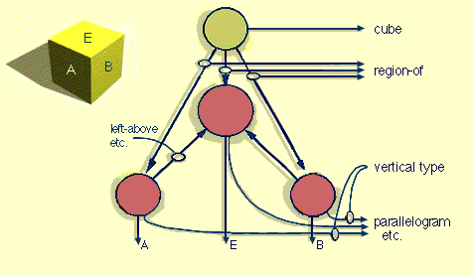
Figure 1 Frame example (Minsky)

Different frames of a given frames system share same terminal nodes. Terminal modes are always valued with “default value” which can be dynamically changed by new (real) values coming from experience. Frames are linked together by an “information retrieval network” able to find the “best” adapted frame for a new situation. The matching process is partly controlled by attached information (which is acquired during the exploring process) and partly by the current goals of the problem to solve. Frames are organized in a hierarchy and are linked transversally by their differences (frames with small differences are close).

Moreover, Marvin Minsky argues that Logic is too restrictive to be efficient in the real world. He writes “thinking begins first with suggestive but defective plans and images that are slowly (if ever) refined and replaced by better ones”.

This theoretical approach lead mainly to Object and Frame Languages but the “analogical reasoning process” has not really been implemented.

Roger Schank : one of the first to speak of Case Based Reasoning
See [SCHANK 1982][SCHANK et al. 1989]

Understanding stories in natural language was one of the first objectives of Schank & al. when he developed his theory on CBR. The basic idea is that mental schemes are guiding the understanding of texts, allowing to fill the “gaps” of what was not said. “Understanding is Explaining” said Robert Schank.

Consider the following sentences: “John went to the restaurant. He got some ham. It was good.”. Understanding this short text needs to know that when we got ham in a restaurant, it is for eating. Nothing of that is said in the text, but we guess that John ate the ham… Robert Schank proposes to represent the behaviour (here, in a restaurant) by a “script” splitting it in different steps which can be finer scripts and so on. See for an illustration of what can be a script.

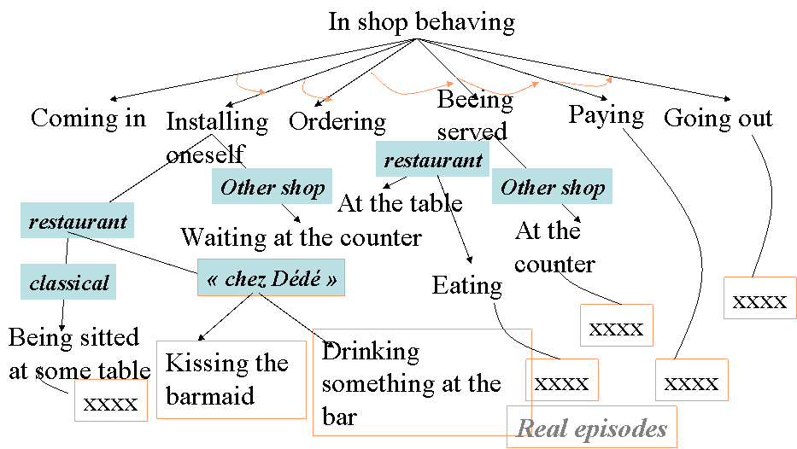
Figure 2 Illustration of a script (Schank)

So, a script describes an episode according to a known behaviour by the way of a sequence of events as they are awaited (usual experimented situations). When a new situation is encountered, the script is adapted to fit with this exception. In order to complete events with useful information, scripts contain other information and mainly:
- Actual goals,
- Current plans,
- Social links,
- Played roles,
- Character traits,
- And generally speaking, anything indicating the behaviour of the script in a given situation.

Scripts and schemas share many properties but what is really different is the status of “immediate experience”. While Minsky argues that frames are “idealistic stereotypes” of encountered situations, Schank proposes to keep in memory “concrete episodes” as they occurred in reality. They are organized in a dynamic memory and reused by adaptation. Episodes memory is self organized by a simple generalization process as illustrated in

Figure 3 Episodes E1 and E2 are combined in order to build their generalization EG. ES1 and ES2 are specializations of EG.
Many researches completed these pioneering works but main concepts were founded and AI technologies integrate now this paradigm of CBR for Problem Solving and Lazzy Learning.

Knowledge and CBR principles
From our point of view, Minsky and Schank were the CBR pioneers (unconsciously for Minsky!), Janet Kolodner worked explicitly on CBR [Kolodner 83] and wrote the first book on the subject in 1993 [Kolodner 93]. From an engineering point of view, Agnar Aamodt and Enric Plazza proposed a CBR reasoning cycle in 1994 and a lot of correlated research works and applications were developed since [http://www.ai-cbr.org].

What is a Case?
A case is the description of a solving problem episode. Its structure fits the situation of the task: diagnostic, planning, decision helping, design, etc. For pedagogical purpose, we consider a case as a list of descriptors (which descriptors can be structures).
A case is composed of a problem part and a solution part: Case=(pb,Sol(pb)). A source case source_case=(source, Sol(Source) is a case from which the solution Sol(Source) will be reuse in order to solve a new problem we call a target case target_case=(target, Sol(target)).
A case is described by descriptors:
- source={d^{s}₁..d^{s}_{n}} where d^{s}_{i} is a source problem descriptor.
- Sol(source)={D^{s}₁..D^{s}m} where D^{s}_{i} is a source solution descriptor
- cible={d^{c}₁..d^{c}_{n}} where d^{c}_{i} is a target problem descriptor.
- Sol(cible)={D^{c}₁..D^{c}_{n}} where D^{c}_{i} is a target solution descriptor.

Example 1:
Consider a problem of finding the adequate price for a flat.
Problem part
d^{s}₁ = Flat surface (real)
d^{s}₂ = Flat location (a structure)
d^{s}₃ = Flat state (a list of defects)
Solution part
D^{c}₁ = Sale price of the flat (real)
D^{c}₂ = Sale conditions (payment facilities for example)
Example 2
Consider a task of car diagnosis.
Problem part
d^{s}₁ = Noises (list of symbolic descriptors)
d^{s}₂ = External symptoms (list of symbolic descriptors)
d^{s}₃ = Car model (symbolic descriptor)
d^{s}₄ = First “circulation” date (date descriptor)
Solution part
D^{c}₁ = Mechanical pieces to troubleshoot (list of symbolic descriptors)
D^{c}₂ = Diagnosed faults on the mechanical pieces

Ontology of attributes of description
To match and compare cases, attribute values have to be compared for similarity evaluation purpose. Each attribute has a type. Knowing the type allows to choose adequate comparison operators. It is useful to describe the ontology of the types of attributes to enable efficient similarity measure not for “describing the world”!

Figure 4 Ontology for the "flat sale problem". There is multiple inheritance for the location which is a kind_of “agglomeration” and a kind_of “town of Département du Rhône”.

Figure 5 Ontology for describing cars for diagnosis purpose

Ontology can be shared by a whole cases base, but it is not mandatory to build such an ontology. Each attribute can have a “facet” explaining how to manage the similarity measure for each specific case. “Pure CBR” embodies any knowledge in cases.

What is a Cases Base?
A Cases Base is a collection of solved cases for a class of problems. For example, there are separate and different cases bases for the “Flat sale problem” and for the “Card diagnosis problem”. For the “Flat sale problem”, a case is the description of a sale episode and descriptors cope with the corresponding ontology. On the following table, green lines stand for problem descriptors and pink line stands for the solution description (here, the sale price).

Attribute label | Case 1 | Case 2 | Case 3 | Attribute type
Pb_Surface | 55 | 35 | 55 | Real
Pb_District_Location | Rhône district | Rhône district | Ain district | Symbol
Sol_Sale_Price | 20000 | 45000 | 15000 | Real
Pb_Flat_Type | F2 | F2 | F2 | Symbol
Pb_Town_Location | Lyon | Lyon | Bourg en Bresse | Symbol
Table 1 A small cases base on the " Flat sale problem"
The district location can be easily inferred from the ontology (see Figure 4). Even if it seems that building a cases base is easier that building a set of rules, there exists Knowledge Engineering problems as we will see in the last section. Most of industrial CBR applications propose a kind of form to describe cases in order to fill the cases base. Cases base can be small (if different possible cases are well represented and that the domain knowledge is rich) or very large (if there exists a wide variety of cases and that the domain knowledge is poor).

For each cases base, there is an associated metric allowing to project cases on the “solution plan”. Similar cases are cases that have similar solutions for similar problems.

Figure 6 Similar cases are evaluated on the solution plan where similar solutions coming from similar problems are projected.

What is the resolution process? How to choose a source case in the cases base?
In a large cases base, there is no chance to be able to adapt any case to a new one with the only support of the domain knowledge (if we could do that, there was not interesting to use CBR!). There is a threshold of similarity to take into account when attempting to adapt a past case for a new one. Moreover, there is no chance to use the same adaptation process for different kind of problems (for example, adapting the price of an old flat is not the same than adapting the price of a new one, even if anything else is very similar). Consequently, similarity measures are used to build dynamic clusters of cases in order to choose which kind of adaptation method has to be chosen for a given new problem.

Figure 7 Clustering cases by "type of adaptation process"
The resolution process is illustrated in Figure 8: similarity of the new target case (C) is computed with all other cases. The algorithm chooses the type of adaptation which is the significant and the most represented in the cluster of neighbors. (C) has been assessed to fit with a “blue” adaptation process.

Figure 8 Resolution process

Case Based Reasoning needs a cases base on which a metric and a similarity measure have been defined.

CBR cycle
Aamodt and Plaza proposed a first CBR cycle to make evident the knowledge engineering effort in CBR. This general cycle has been completed by an “Elaborate” step which was not specified in the original cycle [Aamodt&Plaza 1994].
Each step has his proper way to use knowledge base and cases base but “retrieve” and “adapt” steps explain how to build knowledge representation for domain and cases.
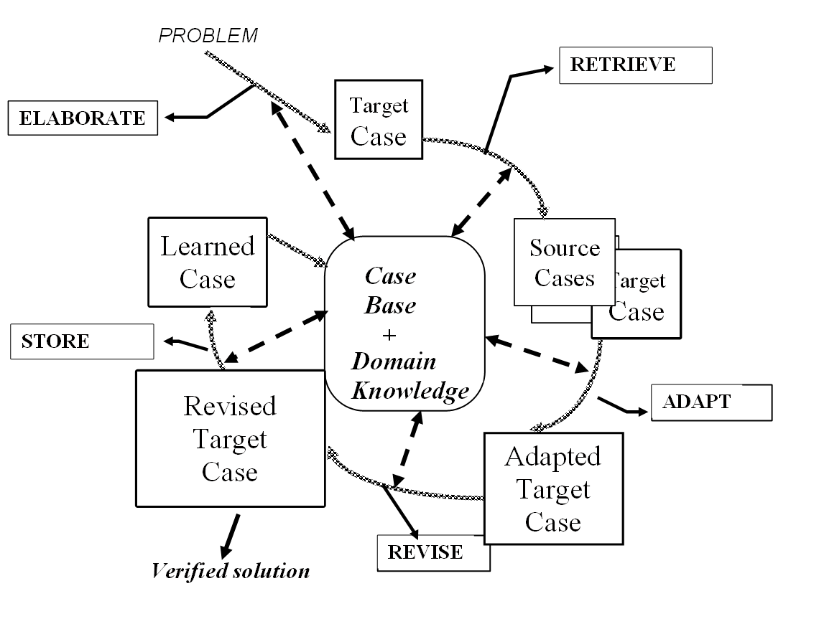
Figure 9 CBR cycle steps

Elaborate
“Elaborate” a new case consists to decide what descriptors are useful for finding “adaptable” cases in the cases base. Similarity is synonym of “adaptability”. Adaptability depends directly on the supposed effort to adapt a source case solution in the context of the target case problem. A general method consists to complete or to filter the raw description of a problem on the basis of domain knowledge, inferring new descriptors and importance weights. Dependencies (β) are very important to be explicitly available at this step. This step “elaborate” is illustrated in Table 2 and Table 3 while Figure 10 illustrates how the domain knowledge can be used to infer a new descriptors from an other one.

Table 2 Problem description to elaborate | Table 3 Elaborated Problem description
  Attribute label | Attribute type | Attribute value
  General status | Symbol (inferred) | ??
  Nb kms | Real | 198000
  Nb of years of the cas | Real | 10
  Car Manufacturer | Symbol (inferred) | ??
  Car model | Symbol | 206
  Car type | Symbol | Break
  Defects | List of symbols | (superficial problems)
  Sale Price (solution) | Real | ???
  Attribute value
  Good
  198000
  10
  Peugeot
  205
  Break
  (superficial problems)
  ???

Figure 10. Domain knowledge to infer « general status » from « list of defects »

Retrieve
The “retrieve” step is the key step in CBR because the quality of the adaptation depends on the quality of the retrieval. Do not forget that we are searching for “similar” solutions by matching source and target problems.
It is necessary to define a similarity measure which will take into account dependencies between problem and solution descriptors and adaptation operators availability for observed discrepancies.
There are numerous similarity measures in literature (coming from data analysis for example) taking into account specificities of descriptors (time, space, complex structures, plans, sequences, etc.). It is often possible to translate these “special” similarity measures in simpler ones by transforming complex descriptors in a set of simpler ones. Intuitively, we understand that we have to give a high weight for problem descriptors exhibiting a high dependency with solution descriptors and for which there is no simple adaptation operators. Conversely, we can put low weights for problem descriptors exhibiting little dependency and for which it is easy to adapt corresponding dependent solution descriptors.
For reason of simplicity, we consider there the following distance measure:
the distance between two problem descriptors is constituted by the weighted summ of attributes distances. Weights p_{i} hold the knowledge on the scale of “influence” of the problem descriptor d_{i} on the solution.

Attribute label | Attribute type | Influence weight of the attribute on the solution
General Status | Symbol (inferred) | 20%
Nb of kms | Real | 35%
Nb of years of the car | Real | 25%
Manufacturer | Symbol (inferred) | 5%
Car Model | Symbol | 5%
Car type | Symbol | 10%
Observed defects list | List of symbols | No importance
Sale Price (solution) | Real | ???
Table 4 Attribute weights = influence importance of the attribute on the solution
Retrieval step consists to use these weights to choose the best case to adapt. The classical algorithm is the KNN algorithm (K nearest neighbors).

Adapt
Adaptation is the end of the analogical inference by computing which could be a target solution by adapting the solution of the most similar case. Adaptation rules have to express how to manage discrepancies between source and target problems to guide adaptation of the source solution. The following schema (**) illustrates knowledge and inference process of adaptation:

Figure 11 Illustration of a single simple adaptation

Single local adaptation rule
This formula expresses that D_{k}^{t} is computed by “adding” the influence I(D_{k}^{s}/d_{i}^{s}) “in proportion of” the difference Δd_{i} between source and problem descriptors. “adding” operator and “in proportion of” operator can be very specific to the types of descriptors and to the context of the case (the type of adaptation to process).

Generally, we have the following adaptation process:

There is a new operator « integrating » the effect of several discrepancies on problems parts.
Consider the following « car sale problem » (Remind screen captures).

The adaptation rule could be the following:

In this rule, we consider only 2 influences of problem descriptors on the price: number of kilometers and car status. Each positive (negative) discrepancy of 1 km on the first descriptor adds (substracts) 0,1 euros to the price while the fact to go from “bad status” to “good status” (or vice-versa) adds 1000 euros (or substracts) 1000 euros.

Revise
Revising is sometimes necessary when the adapted solution did not fit the current situation and needs “revisions” to fit it. In order to revise, we can:
- Try the adapted solution in the “real” world (for example, we try to sell our car with the adapted sale price…).
- Introspect the cases base with the complete case in order to verify how similar complete cases worked when applied (for example, we could verify that similar cars were really sold with a similar price).
- Use an other problem solving process (simulator, expert system, …)

In each case, we can observe discrepancies between what the system proposed and what would have been a correct proposal. After the revising step, we could use these discrepancies as starting points to revise the domain knowledge and to learn about the retrieval/adaptation process.

Memorize (learn)

Adding a new real solved case to the Cases Base is the basic “learning” mechanism of CBR. Other important things can be capitalized:
- As noticed for the “revise” step, retrieval and adaptation knowledge:
  - Similarity measure
  - Influence knowledge
  - New dependencies, etc
- The “trace” of the “reasoning process” as it was for the current new case. For example, if we keep trace of the adaptation process, we can consider these traces as “adaptation cases” usable for a CBR cycle for the adaptation problem.

CBR knowledge engineering

Very shortly, we can summarize important steps we usually find during knowledge engineering for a CBR application:
- Collecting potential “cases”
- Describing case descriptors
- Testing cases structures with “users/experts”
- Trying to build an ontology of descriptors attributes
- Observing the reusing of cases by users/experts for real concrete problems.
- Focusing on the adaptation process
- Eliciting dependencies and influences as they are used in adaptation
- Building a similarity measure on the base of known dependencies and influences
- Testing similarity measure with the set of solved cases
- Building adaptation rules according to dependencies and influences
- Testing adaptation on the set of known cases
- Building new cases with “normal” users with “observers/experts” (we call this period the “learning” period of the system)
- Revising the whole system
- Delivering the CBR system with an initial “cases base” useful for reusing…and continuous learning possibilities!

Traces Based Reasoning
We share the idea that human experience, temporally situated by definition, is well represented by a temporal record or trace describing an implicit underlying process. CBR claims also that property by addressing problem solving episodes, even if \emph{de facto} CBR systems exploiting the temporal dimension of cases are not so numerous; case descriptors are not compulsorily time stamped. Moreover, a problem solving episode is considered independently of the different "stories" (contexts) where this episode occurred. A case is described with a fixed granularity, in a specific temporality and contains intangible description terms.
According to our opinion, we proposed to exploit use traces of a computer environment as possible indirect records of knowledge which emerged while the user did his/her tasks with the help of the computer environment. We propose a theory defining what we call a "trace", how it can be represented and which kind of computations can be done in order to retrieve useful past sequences for new uses.
When traces are exploited on the basis of pattern similarities allowing some adaptations to new situations, we propose to call this kind of computation "Traces Based Reasoning" (TBR). TBR is a kind of generalization of CBR principles.
By analogy with CBR, the TBR cycle would be illustrated as figured in 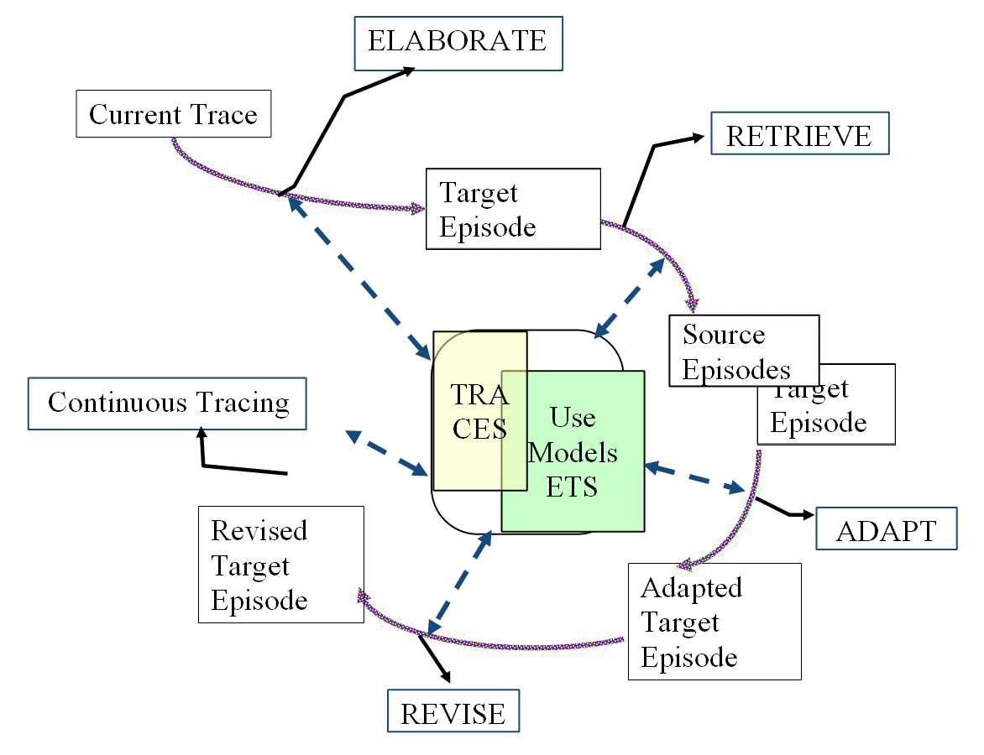
Figure 12 The CBR cycle handles cases, which are stored in a case base, under a predefined form; the TBR cycle dynamically elaborates episodes which could be potentially useful in available traces according to some "task signature"; the target episode is built with the help of other proposed episodes under the user control. The target episode belongs to the current trace, it will be stored in it without particular indexing. Stored traces are containers of potential episodes which will be revealed in new situations.

As for CBR, we consider that most of the reasoning cycle steps can be realized by the computer environment or/and by the user himself. In the next parts, we present what we propose to call "trace theory" with the MUSETTE model as a starting point. Then, we illustrate TBR by an Intelligent Tutoring System where traces are used to help the learning process.

Discussion

Cases base can be structured in order to cut the number of matches to do.
In order to take into account the « car status », it would be possible to express it by a « mark » between 1 to 10 for example and to use classical metrics.

